# Bucket List Dream Accomplished in the Italian Alps

Three countries in one week. Wowza! It's been fabulous, though, especially because I know I'm on the home stretch of this month long trip! I naively thought that I needed a great deal of time to accomplish all the things on my list. But having to stay on top of so many details

every single day

can get a little exhausting. I'm still enjoying the sights and the experiences, but I'm also really looking forward to being home. And staying home. For a long time. :)

(Photo below: Innsbruck, Austria)

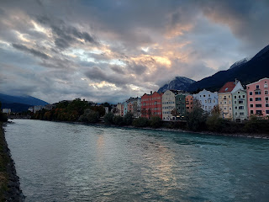

Monday:

I knew that rain was in the forecast for Tuesday, so I took advantage of the nicer weather for the start of the week by going on a walk into the forest above Ofterdingen. I chose a hike called Nagels Hutte, an easy, yet somewhat long hike. Nagels Hutte is a "warming hut" up in the forest, nestled among the many trails that hikers use in the winter. There's even a fire pit next to the hut.

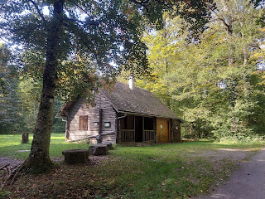

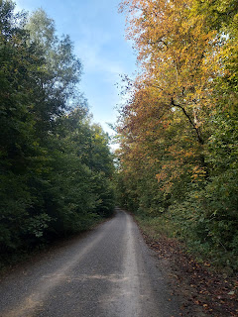

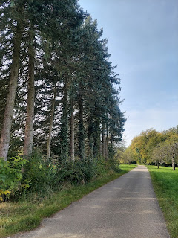

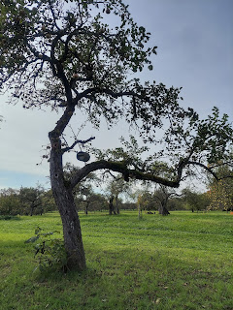

Not only did I find the German equivalent of the Sacred Grove (in Palmyra, New York) . . .

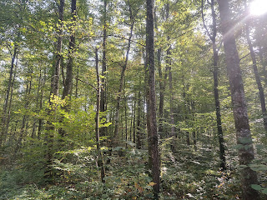

But I also found the mother lode of apple orchards as well! Last week I learned from the German genealogist (Karin) that there are roughly 1,000 varieties of apples in Ofterdingen and Mossingen. Well, I think that I hit the jackpot on this trail.

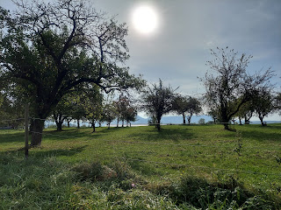

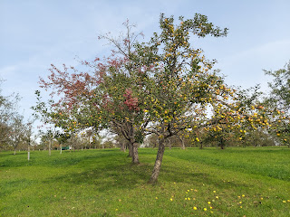

I wanted to pick one and eat it so badly. But I didn't want to end up in a German jail either. You gotta choose wisely.

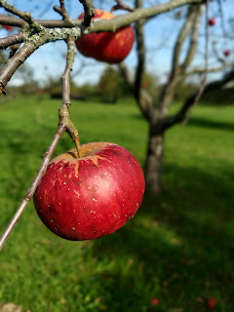

Because my hike into the forest took about 2 hours, I was able to listen to an entire session of general conference! I chose the Saturday evening session and wow, was it wonderful! I especially loved Brad Wilcox's talk, entitled: "Worthiness is Not Flawlessness". He told of a young man, who struggled with a difficult addiction and hated himself for years for not being able to get things under control. Once he was taught correct principles about repentance and how the Atonement of Jesus Christ can transform us, he said: "These days I spend a lot less time hating myself for what I have done and a lot more time loving Jesus for what He has done." Wow. Just wow.

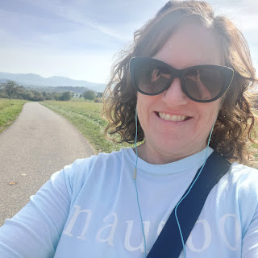

Distant views of Ofterdingen from the trail . . .

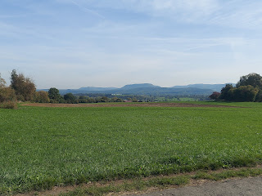

This was my route up to the Hut. One hour up. And one hour to get back.

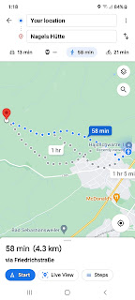

I went back to my little house for lunch and a short rest before heading out on another walk around town. Ofterdingen is small, but even though I walked and walked and walked over the course of several days, I still did not cover every square inch of it. I enjoyed wandering around, though, trying to imagine where my Schmid ancestors may have lived.

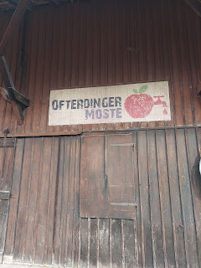

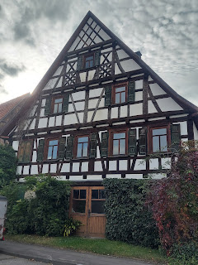

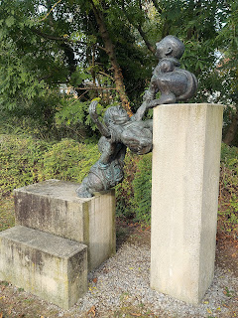

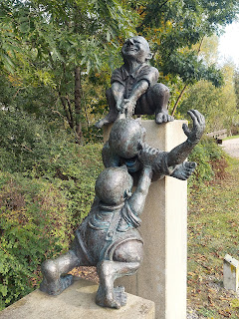

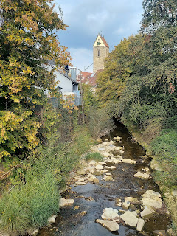

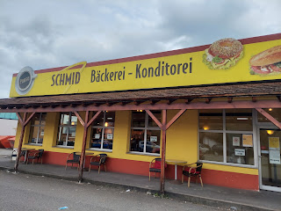

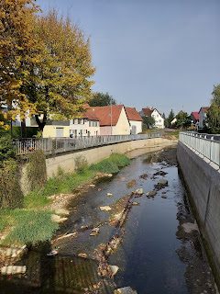

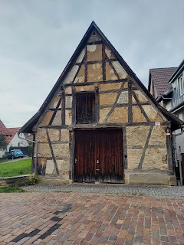

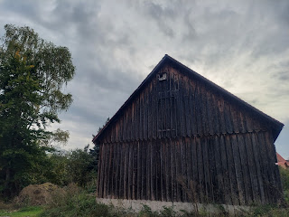

Once in a while you see something like this driving down the street. :)

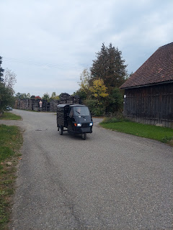

I had passed this sign a few times before, close to my AirBnB, but hadn't taken the detour yet. This day I decided, why not? It took me over a little bridge and across the stream. Schmid is a family surname, but I didn't know what GmbH meant.

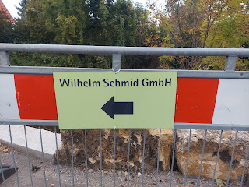

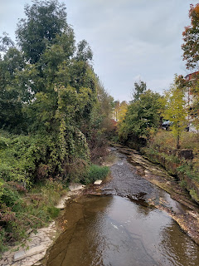

GmbH means:

GmbH is a German abbreviation for “Gesellschaft mit beschränkter Haftung,” meaning, "company with limited liability."

So basically it means: Ltd. I'm not sure what Wilhelm's business is, but I couldn't find any more signs directing me to his shop. It was just a quaint and quiet neighborhood.

Eventually, I went back to my house for a short rest again before heading into town for a nice dinner. I had been just "winging it" all weekend long, but I was craving something with a little more pizzazz. For 2 1/2 days I was eating a mixture of the following: boiled eggs, sliced cucumbers, cherry tomatoes, bananas, pears, or a sandwich. Not bad. But I was ready for more interesting flavors. :)

My host, Peter, made me a reservation at the "Ochsen" restaurant - pronounced Oxen, a popular (and fancy) chain in the area. I ordered the tomato soup, along with Cordon Bleu and a side salad.

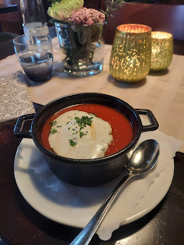

Everything was delicious! I found the salad most interesting because it looked like just one type of salad from first glance. But underneath the lettuce and shredded radishes on top, it was like they gave me a tiny bit of every kind of German salad that was ever created, ha ha! Later I realized that it was called Mixed Salad. They were accurate, ha ha. I just hadn't noticed . . .

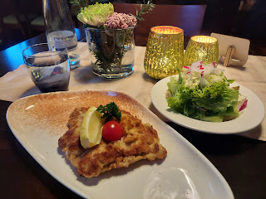

There was a lettuce salad on top with dressing. There was also cole slaw. And pickled cucumbers. And German potato salad. And 5 bean salad (with pickled green beans, etc.). It was fun to try everything all in one bowl!

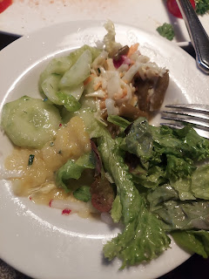

I also got a couple of photos from Chelsea, who celebrated her 32nd birthday on Sunday. She and Garret, along with all their friends, had a birthday party at the skating rink!! How cute is that!!

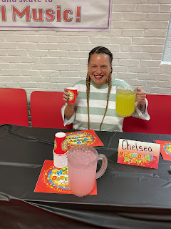

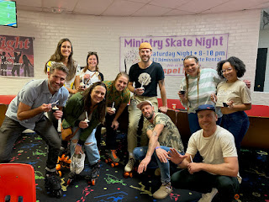

And look at Garret with his backwards skating skills!! (6 seconds)

https://photos.app.goo.gl/1KDZr2fvxLXWstPZ8

Man, I love skating! I wish I could have been there!

Speaking of birthdays, Kylie had a birthday on the same day as Chelsea! I was able to visit with her on the phone for a bit and see how she's doing. So far, so good! Baby has dropped, she says, and she is counting down the weeks until her due date. She is 34 weeks along right now, and the longer Little One stays in her tummy, the better. :) Next week, she will be able to resume normal activities again, finally ending her strict bed rest. She is looking forward to that!

I will be there soon as well! I am hoping to find a few things to help with around their house while Benson is at work or sleeping. But mostly I am just looking forward to hugs from family members after being on the road for so long by myself. It will be good to spend a little time with them, not only because I love them so much, but because they speak ENGLISH!!!

Tuesday:

I traveled to Tubingen, Germany, a short distance to the north of Ofterdingen. Several people had encouraged me to go and check it out while I was in the area. First thing off the train I noticed this bright and blaring building as I walked toward the river.

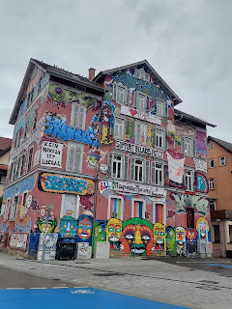

Then it was across the river and into the Old Town of Tubingen. It was quite lovely.

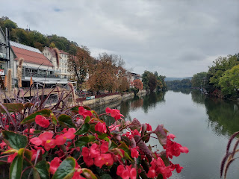

This old church, known as St. George's Collegiate Church, was built in 1470.

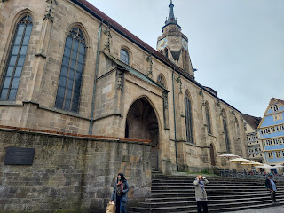

I loved seeing this little farmer's market on one side of the church.

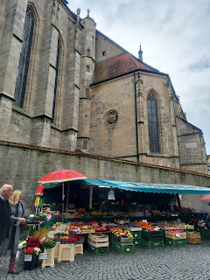

Surrounding the old church, are several streets filled with old - and I mean OLD - buildings. The buildings have been refurbished to currently serve as lots of fun little shops.

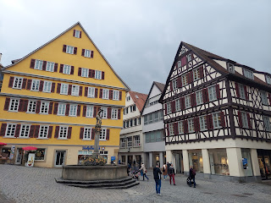

While upstairs in this building there was more evidence of political and social unrest, downstairs there was a variety of gelato to be bought and eaten.

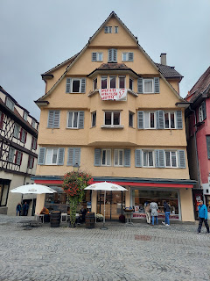

After a couple hours of browsing, eating and shopping, it was time to get on the train back to Mossingen and Ofterdingen. Goodbye university town with your beautiful river!

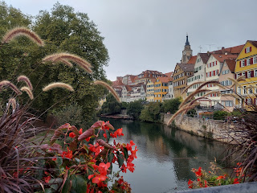

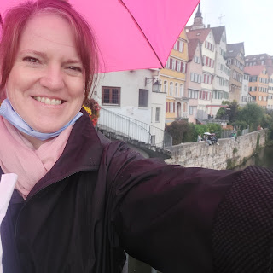

When I got back to my little house, I prepared 2 boxes to be shipped back to the U.S. One would be shipped home to me, and the other would be sent to my family in CA, full of little goodies from the area where our ancestors came from. Yay!

I mailed them successfully from the Deutsche Post Office, close to the Ofterdingen Church that I had visited numerous times. I needed to go say goodbye to the church one last time. It only seemed right that I do so before leaving town the next day.

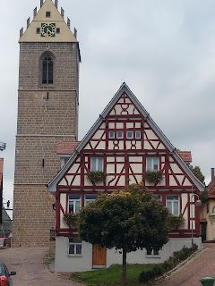

This time, to my great surprise, the door of the church was OPEN!!

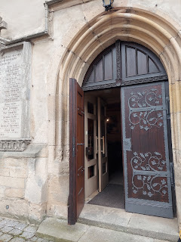

So I went in. There was a small group of people talking inside, so I tried not to intrude too much. I took a couple of quick pictures and then quietly left. At least I got to see the inside though! That was unexpected, and awesome!

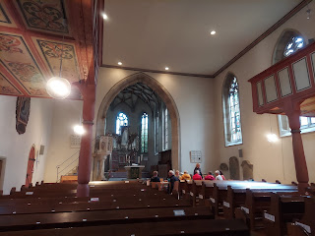

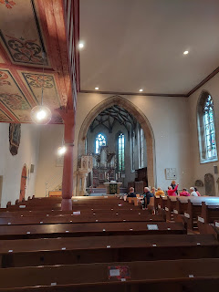

I am so grateful for my time in Ofterdingen and Mossingen. What a treasure that week was, and I will always remember my stay there.

The best purchase that I found in Tubingen was this cute wool coat, which I knew I would need soon - as I would be heading to Austria. It was only $50!! It's super heavy and quite warm. I was really suprised that it only cost that much. In Switzerland it probably would have cost $200. Same in the U.S.

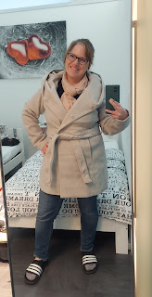

Wednesday

- *NOTE - I'm in Italy right now as I'm typing the rest of my blog and this keyboard is so weird!! Several symbols that I'm used to using - like the colon and parentheses - are not available. I've tried everything I can think of to make them work, but haven't figured it out yet.

I was sad to say goodbye to Peter, my host in Ofterdingen. He was just the best! He drove me to the train station early in the morning, and then he headed off to drive all the way to Munich and back in one day. He had been wanting a fold-out bed to install in his van for when they drive down to Spain. It would have taken weeks to order it online, or he could drive to Munich and pick it up himself. So he did! He's so cool.

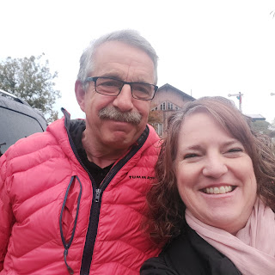

On the train ride to Austria, it was simply awe-inspiring to see all the idyllic scenery passing by. Southern Germany was every bit as gorgeous as Austria, too.

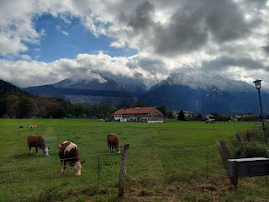

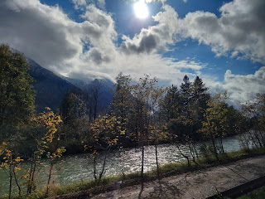

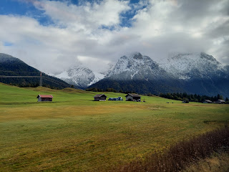

Try pronouncing this next train stop. Just try.

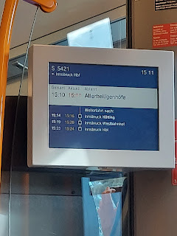

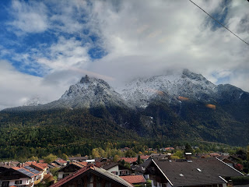

Finally, after about 6 hours of train travel, I arrived in Innsbruck, Austria. Simply amazing.

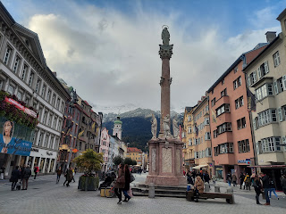



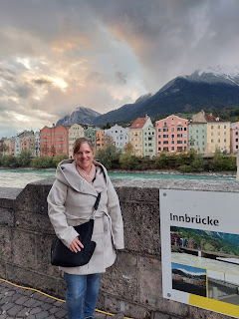

After a meal and some exploring, I found this famous landmark for Innsbruck. It's called the Golden Roof.

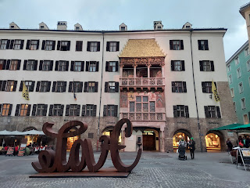

Here is the explanation.

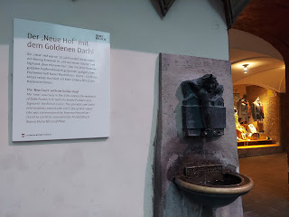

Outdoor dining here is not for the faint of heart. It was cold enough for me that I stopped in a store to buy some gloves!

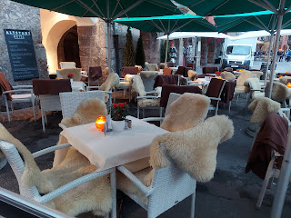

I wished that I had the budget to splurge on some cute accessories like these . . .

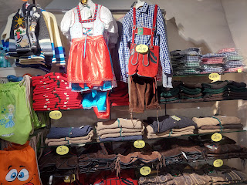

As the sky was getting dark, it was time to get back to my hotel for the night.

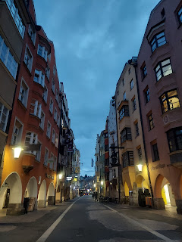

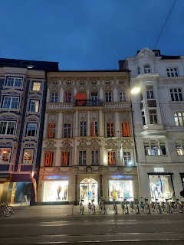

Thursday

- I was excited to start the day because I would be going up yet another mountain!!

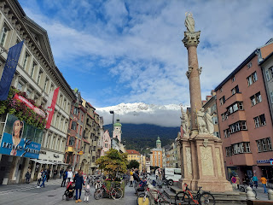

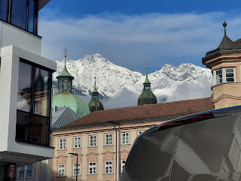

On my walk across town, I found a few familiar things that made me happy. Seeing a T-Mobile store in other areas of the world is reassuring. Just in case I need them . . .

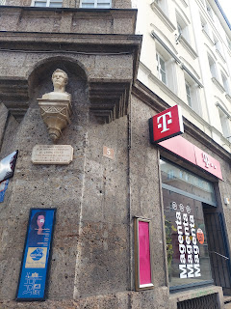

And everywhere I see beautiful plants and flowers, I always think of my sister, Charmaine. I know she would stop and investigate, smell them, touch them, and take a picture or two. Without a doubt.

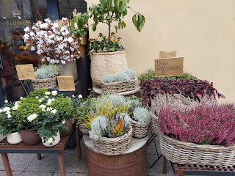

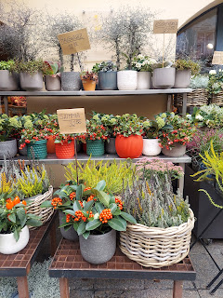

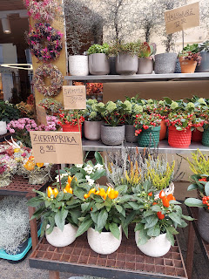

I should mention here that Innsbruck, Austria is famous for hosting the Olympics THREE times!! The only other place that has hosted 3x is London. Innsbruck literally has all the mountains within about 15-20 minutes. They still have a lot of Olympic venues around, including an epic ski jump that I wanted to get to, but I ran out of time in the day.

Instead, I had a date to take a funicular and some cable cars up the mountain. This is the entrance to the funicular at Hungerburg Station.

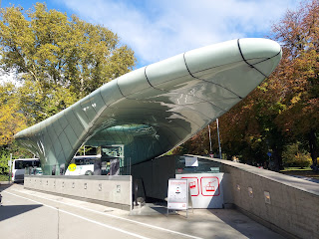

After starting in a dark tunnel, similar to a Disneyland ride, we came out alongside the beautiful teal Inn River.

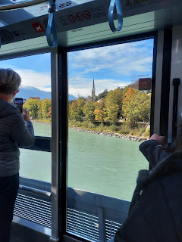

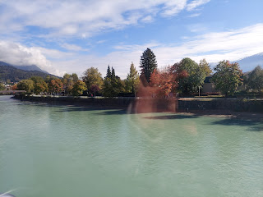

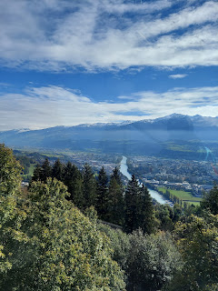

This is where the funicular ended.

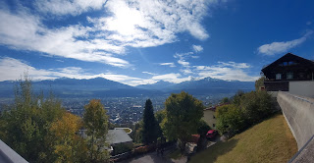

Then it was time to board cable car number 1.

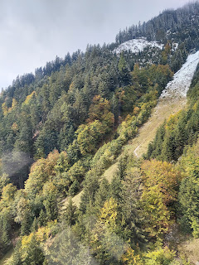

Short video in the cable car as we approached the snow. *Imagine parentheses here - 11 seconds

https://photos.app.goo.gl/Y8y3tYLnbCTmHVz66

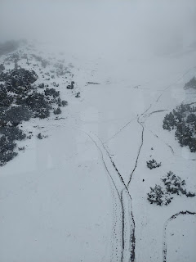

As we got off the first cable car, we were treated to some giant maps of the mountains. I was headed up the Hafelekerbahn all the way to the top. The funicular on this map was labeled as Seegrubenbahn. And the station I was currently at was called Seegrube.

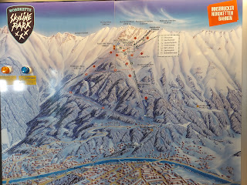

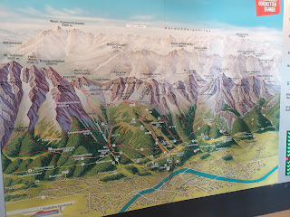

On the last cable car ascent, this was the awe-inspiring view.

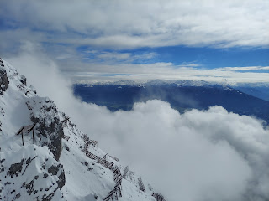

You could even see Italy way off in the distance. Wowza.

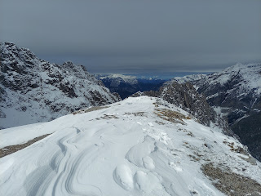

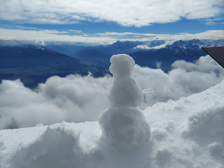

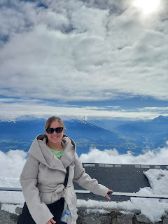

Truly it felt like you were on top of the world.

And yes, in case you were wondering, the hills were indeed alive. So I just had to do it. Quietly, of course, ha ha.

Video of me singing - 28 seconds

https://photos.app.goo.gl/ZuJZentcaXrSbzDe8

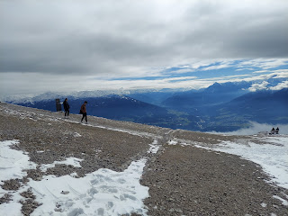

That last cable car was really quite amazing. At times you couldn't see anything but the clouds.

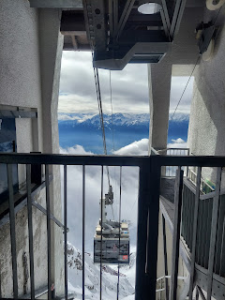

This was the view while waiting for the cable car to come back up to get us and take us back down.

I like to call this -

Faith

.

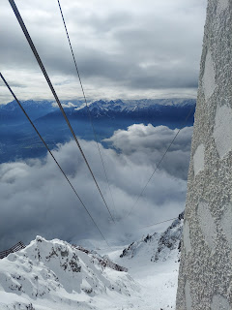

Here is the video of our 2 minute descent into the abyss. Think of a time when you had worries or fears, and you didn't know what the outcome would be. Who do you turn to for help. What do you put your faith in, or rather WHO do you put your faith in, knowing that eventually it will be okay. *Again, no question marks are available on this Italian keyboard, LOL.

https://photos.app.goo.gl/jzUqw215UYXjHoir8

Half-way down the  mountain, I stopped to get lunch at this cute outdoor restaurant. It had cuisine local to the Tyrol area of Austria, so I decided to give it a try.

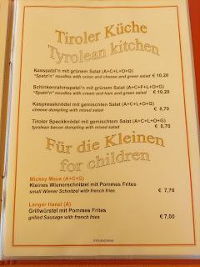

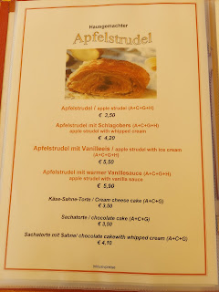

I chose the Tyrolean Bacon Dumpling with mixed salad - again, ha ha.

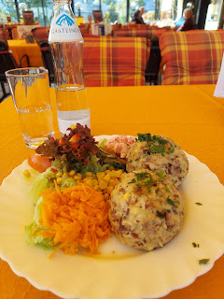

It was like a giant stuffing ball with bacon and other goodies in it. It was really good! But it was even better when I mixed each bite with something sour or vinegary - like the cucumbers, or pickled radishes.

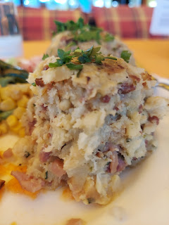

Per the waitress' suggestion, I chose the cheese cake for dessert. Talk about a huge slice of pie! I only ate about half of it.

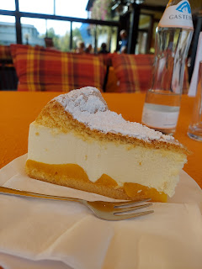

In Europe, eating is a slow and relaxed affair. Nobody rushes through the meal like we do in America. In America, it's like we eat to just check it off a list and then move on to whatever else is next. But in Europe, this IS the event. It takes forever to get through a meal at a restaurant. I try to use it as a time to make a phone call or get caught up on emails while I wait.

I got a kick out of these old guys playing cards together for a really long time. They were having such a good time and that's awesome! It's nice to see people slow down and just savor an afternoon with friends.

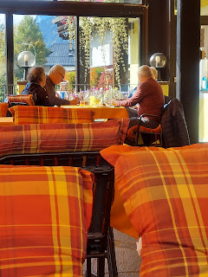

Next, I got off the funicular part-way down so that I could go to the Alpine Zoo. Apparently it's the highest elevation zoo in Europe, so that's pretty cool.

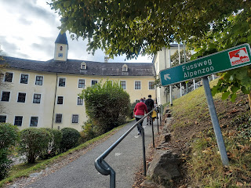

If you're into wolves, you would have loved this little mysterious nook.

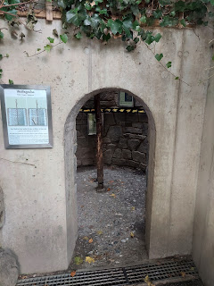

This is what I found inside. *48 seconds*

https://photos.app.goo.gl/3DPEQu8jFktENpWD8

And then, adjacent to this little den was the actual wolf encounter. *9 seconds*

https://photos.app.goo.gl/aVZMANNsSYWU1wa6A

It was a beautiful day to go to the zoo.

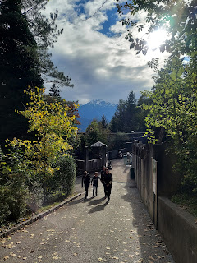

I didn't realize that bison were also in Europe. I thought they were just in my neighborhood back home, as part of the Old West.

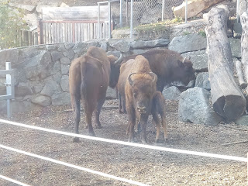

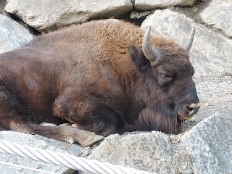

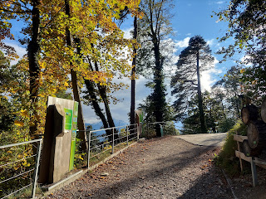

This adult moose was kind of tangled up in the brush. Then a younger moose came over to investigate in this next video. *57 seconds*

https://photos.app.goo.gl/8vSm4QbNP4RwNdD3A

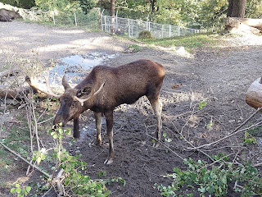

And then there was this HUGE pen full of mountain goats. They were pretty entertaining! The older ones had the longest horns . . . and the little baby ones were so cute jumping from rock to rock and bleating as they went along.

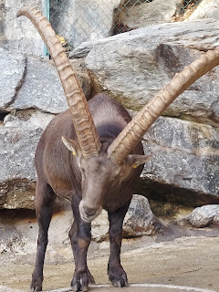

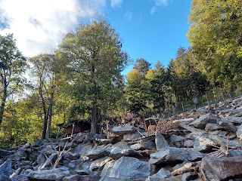

Video of the goats. *24 seconds*

https://photos.app.goo.gl/XZ4wadYaSUsdaarh9

As my legs were getting tired of walking, I decided to head back down the mountain and walk back to my hotel. Across the street from my hotel was this giant arch. I couldn't find anything to really identify it, but I knew it was something important.

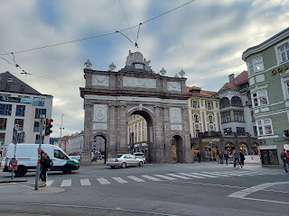

You can see my hotel through the opening - the green one on the corner.

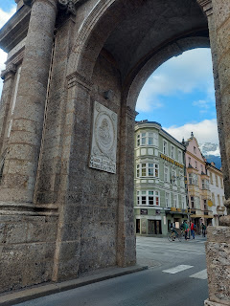

I went out one last time that evening in search of food. I love this photo because not only is it the main drag from my hotel to the Old Town, and I loved walking up and down this street every day, but it also shows exactly where I went up the mountain earlier! If you notice the two main sets of lights up high - the lower left one is where the cable car took us up that last stretch. The lights up at the very top are where we ended up. WOW.

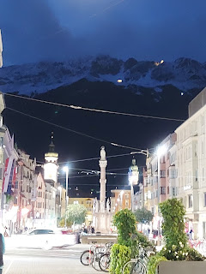

Friday

- I got up early, too early in fact because whenever I know that I need to get up early, my brain always wakes up even earlier!!

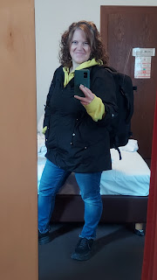

So here's a crazy train story for ya. I arrived at the train platform plenty early in Innsbruck. My train arrived on time, but man was it a crazy circus. Everyone was trying to get on the train, but at least half of the seats were marked as Reserved. People were crammed into the walkways with all their gear, luggage, bicycles, strollers, pets, etc. and everyone was trying to figure out where to sit and where to stash their stuff. I was right there in the mix, too, only I don't speak German.

Somehow I ended up with 2 ladies, one older and one younger, who spoke enough English to understand my predicament and they offered to take me under their wing. They fought tooth and nail to secure us all a seat and to find a place to stash our luggage. I ended up sitting with Marie, the younger girl for the next 2 hours.

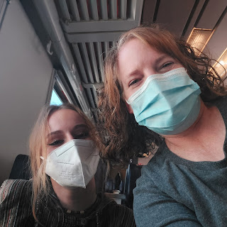

She explained to me that because of Covid, a lot of people pay extra to reserve a seat when they book a train ticket. But the trick is to find a spot that isn't being used CURRENTLY, and to bravely occupy it until you get kicked out at some point when the customer eventually boards the train. We lucked out and didn't have to move during our time on that particular train.

I had a lovely conversation with her for about an hour. She lives about 60 km outside of Innsbruck and is traveling to Italy for school. She was very interested in family history and asked a lot of questions. She even wanted to know technical stuff, like how do you know if this is the right record for your ancestor, and how do you actually ADD people to make your tree get bigger. I hope I taught her enough to get her started . . . there are always regrets later, like did I do enough . . .

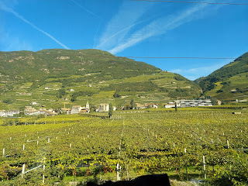

The mountains between Innsbruck and Trento, Italy were spectacular. I didn't get many pictures because either there was a bright sunshiny glare on the window, or I wasn't sitting close enough to get a good picture out the window, or we were too busy talking. But trust me, it was stunning!!

When I switched trains at Trento, there was a bit of a situation on that train as well. I've been learning that if you want a seat AND a place to stash your luggage, you need to get to the doors as quickly as possible. But everyone else knows that as well. So good luck! And when in Italy, good luck even more. Italians are very strong personalities, and are not as gracious as those in Switzerland and Germany.

Somehow I managed to secure a seat, only to be moved by the train attendant to another location, which ended up being much more comfortable anyway. I watched in surprise, then later it turned to shock, when I saw how many people continuously boarded the train at every stop heading up the mountain. The train was small, and was just a commuter train. This was one that stops at every single spot, no matter how tiny or remote it is. People just kept getting on and getting on! I was worried the train wouldn't be able to get up the mountain, but miraculously it did. And finally, little by little, the sardines began to get off the train, and we weren't so packed and squished all together.

I finally arrived in Bassano del Grappa, up in the mountains of Italy, and land of my ancestors, the Bassanos. Earlier in the week, I scrambled to change my entire schedule for this coming week because I saw that rain was in the forecast. Rain equals no paragliding, and I was bound and determined to make sure that didn't happen!!

I said a prayer, asking that if it was a good idea to change all my plans and go earlier to Bassano del Grappa - for better weather - that Heavenly Father would help things to fall into place. I had to change my appointment for paragliding first, then change my lodging, and get train tickets, etc. But it all lined up nicely and I knew that it was the right thing to do.

I was grateful because this was a dream of mine . . . more on that in a minute.

ANYWAY - I arrived at my hotel safely in Bassano via a taxi this time. It was roughly a 28 minute walk from the train station to the hotel, and I didn't want to drag my suitcase all that way after I had already been on trains for 6 hours.

This hotel is very nice, but the internet has been a problem on my laptop here. They have a login page to use the free internet, and on my cellphone it had me first check the box to acknowledge their expectations. On my laptop I never got that acknowledgement page, therefore I don't have any internet access. The hotel staff couldn't figure it out. Scott couldn't figure it out either. We tried everything we could think of, but no luck. So I've been limited to whatever I can do on my phone, and that is why I am here now in the hotel lobby finishing up this blog, ha ha.

Here is my beautiful and sweet husband, trying to help me figure out how to get some internet while he was on his lunch break at school. I sure love him a lot.

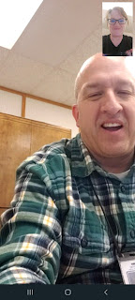

And here is sweet little Abby in Louisiana. I love when Amber posts pictures of the girls. I miss them so much! Gwen will be turning 4 this week! WOW, how time flies.

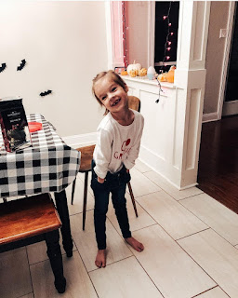

Saturday

- I woke up all kinds of excited because TODAY was the day!!!

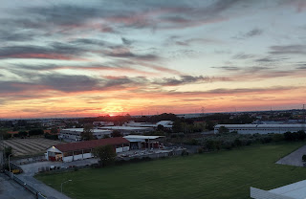

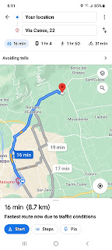

Today was the day that my childhood dream would come true!!!!!!

When I was a little girl, I had a dream repeatedly that I could fly. I would climb out my bedroom window and up onto the roof. I would put my arms out and just lift off, flying effortlessly over the town. I felt like I was free and powerful and majestic. What a wonderful dream to have experienced over and over as a child. It was truly magical.

When I was researching what to do in Bassano del Grappa, I read that this is a prime area for paragliding enthusiasts. The weather is very predictable much of the year, and lends itself to a great launching point for those skilled in the craft of paragliding. I decided right then and there that this was a MUST DO item on my agenda while I was in the area.

The only time I felt my nerves starting to get out of control was when I was still in the hotel room. I hadn't even left yet!! ha ha

I put on some Peace and Calming essential oil to help calm me down, and it sure did the trick. From that point on, I didn't experience one little bit of nervousness. Not even once.

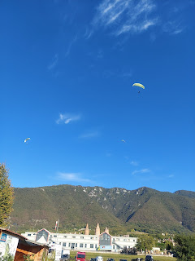

From the starting point - and ending point - I was able to see where we would be launching from. There's sort of a bald spot under the red arrow. That's where they have a huge launch pad covered in astro turf. It's steep but secure.

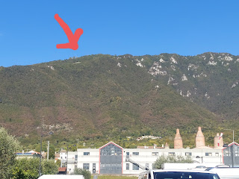

I was paired up with my tandem pilot, named Gabriela. She is originally from Switzerland, but has been in Italy for some time now. She spoke really good English, which is why they assigned her to me.

I had to leave my cell phone behind with my purse so that it didn't fall out during the flight. So I wasn't able to get any of my own pictures except for this video of someone else landing - while I waited to go up the mountain.

Video of someone else landing - *22 seconds*

https://photos.app.goo.gl/gs9YzPuQUM76A3yg9

Finally, it was time to go up the mountain. We all loaded into a minivan with all the gear crammed into the trunk. I was lucky to be able to sit in the front seat, in between the driver and another lady. This was a blessing because on a curvy road such as that, if I had been sitting in the back, I would have gotten pretty carsick by the time we got up to the top! I said a silent prayer of thanks . . .

After several switchbacks, we arrived up at the top about 15 minutes later.

Gabriela helped me get into my harness and helmet, and we practiced the commands together.

Michele, are you ready.

Walk walk walk - Run run run!!

She made sure I understood that when she told me to run, it needed to be with determination, not just going through the motions.

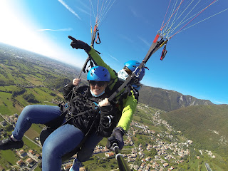

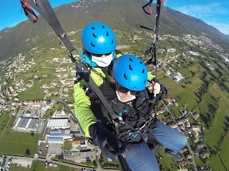

A lady that works for Mt. Grappa Tandem Paragliding took a video of our take-off, which they shared via WhatsApp on my phone. So I was able to upload it to Google photos just fine.

Here is our take-off - *9 seconds*

https://photos.app.goo.gl/mwxqu2pDFJVSjtRz8

**I have to apologize because it was quite windy up there. You will hear a mix of our conversation along with the wind as we turn from time to time. Adjust your volume accordingly.

Video of Gabriela doing the final check with me on the launch pad - *20 seconds*

https://photos.app.goo.gl/9j7HSQVcjEjne9fKA

Video of us early in the flight - *1 min, 17 sec*

https://photos.app.goo.gl/zgRviK4cSAhBoPYs8

Video of us coming in to land - *2 min, 56 sec*

https://photos.app.goo.gl/WTjpCbV8Mjmr233m8

It was the greatest and most exhilarating experience of my life!! It was most definitely a dream come true. It was so smooth up in the air, there was no zero-gravity experience, no motion sickness, no tickle-in-the-tummy sensation. It was just so smooth and effortless. The air was quite cold up there, so I was glad I was wearing 2 jackets. I wish with all my heart that I can do this again someday. It really ignited something within me . . .

Plus I got this t-shirt!!

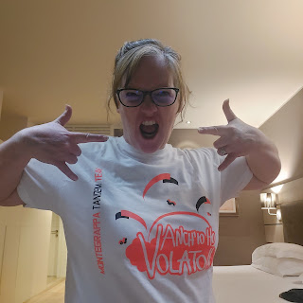

Here's what it says and what it means in Italian -



To see all the photos from the flight:

https://photos.app.goo.gl/QR5LFbJR9hCaUfow7

I'm so glad that I was able to change my schedule to be here now. The weather could not have been more perfect!! Gabriela said it's a rare day when you can see all the way to Venice and the ocean like we were able to see. I am so grateful that I could do this and that I could come to Bassano del Grappa, even if it was on a jam-packed train for hours and hours.

After the flight was over and I got my video footage on the thumb drive, I went via taxi into Bassano del Grappa to create my own walking adventures for the rest of the day. I began at the famous Ponte Vecchio Bridge. It was originally created with wood, and over the centuries it has been destroyed THREE times! During wars of course. Each time, they called upon expert craftsmen and engineers to recreate it just as the original bridge was, in order to preserve the history of Bassano.

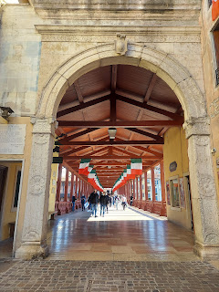

View from the bridge, looking at the River Brenta.

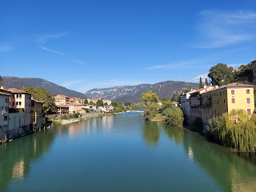

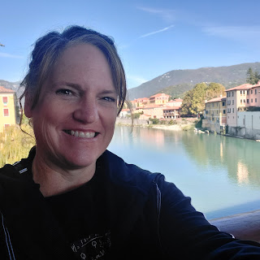

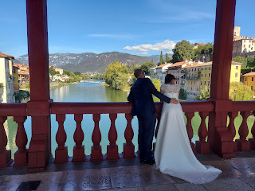

My lunch - Mediterranean Bruschetta.

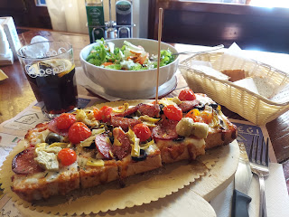

Then I went to the Civic Museum, filled with local history and artwork by the famous Italian painter Jacopo Da Ponte, also known as Jacopo Bassano. I have yet to find the link on my family tree, but give me a little more time and I will figure it out!

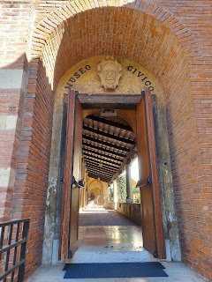

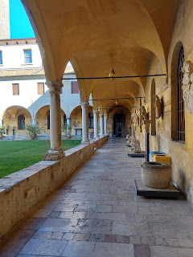

The Museum is housed in a former monastery and old church named San Francesco. Some of the Bassano family members are buried somewhere here. Probably underground in a vault is my guess.

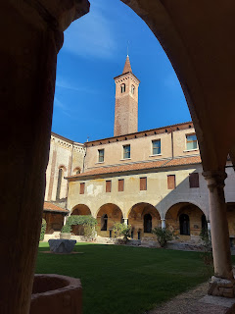

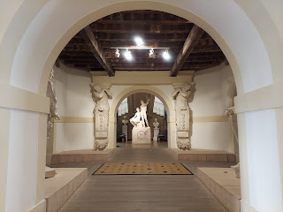

Some highlights from the Museum.

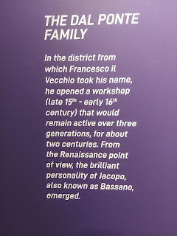

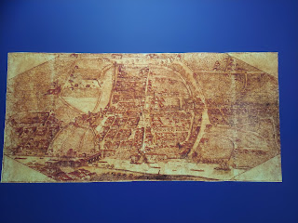

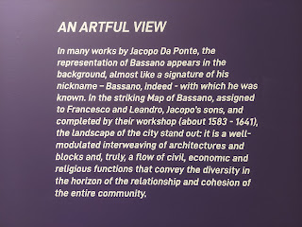

A replica of the original wooden bridge known as Ponte Vecchio.

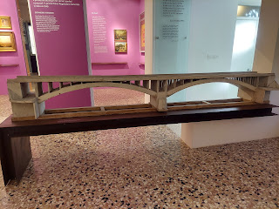

A painting of the alleged house where Jacopo Da Ponte - Bassano - was born.

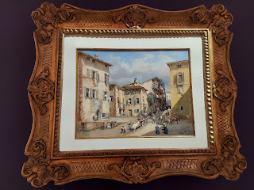

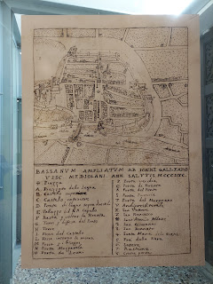

An explanation of some ancient tools that were discovered in the area.

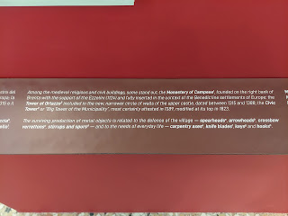

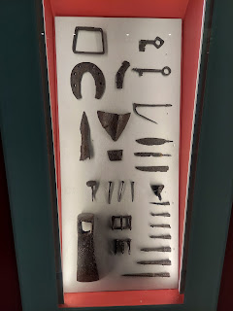

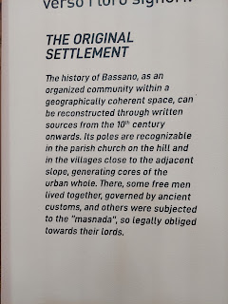

A self-portrait of Jacopo Da Ponte - Bassano. I had to take the photo from a weird angle because of the glare . . .

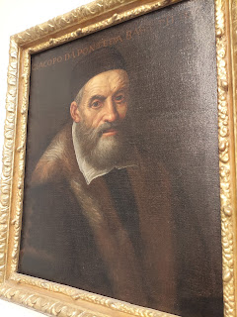

Some of his many paintings, along with their explanation below.

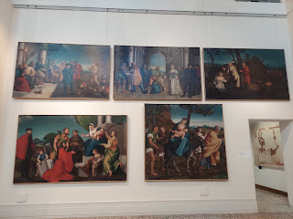

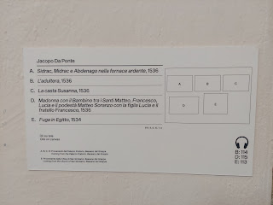

I find it hard to believe that we WOULDN'T be related through the Bassano family. If Jacopo and his descendants were artists and painters, and MY Bassanos were musicians as well as painters, it makes sense that they would share some DNA. I will figure this out at some point . . .

The Museum also houses some interesting ancient artifacts from Italy in general, including this old Corinthian helmet, dated back to about 550 BC.

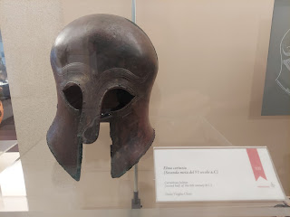

Here are some examples of the jewelry that was worn in the Hellenistic Age. *323-33 BC.

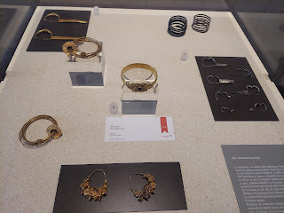

After my leisurely tour of the Museum was complete, I enjoyed walking the long hallways outside in the courtyard of the old monastery.

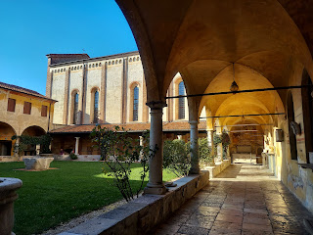

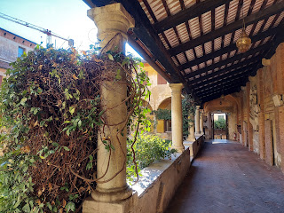

Just as I was about to exit, I saw this old piece of stone. I saw later that it was mentioned in my museum booklet, saying that it was part of a Bassano headstone that was recovered at some point. Wow! I'm so glad I happened to see it before I left!

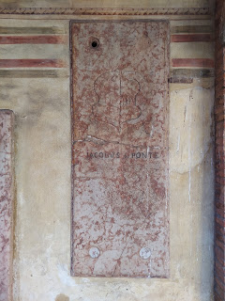

I walked a couple streets over so that I could stroll down Jacopo Da Ponte Street.

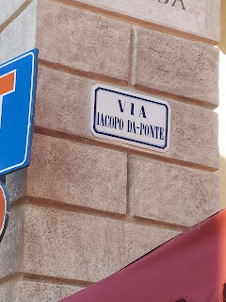

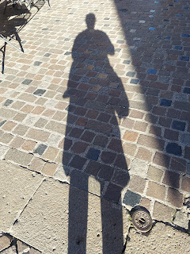

That's when I came across this delightful old man, playing his accordion. That was a nice touch.

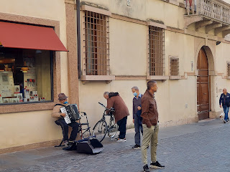

Short video of him playing - *23 seconds*

https://photos.app.goo.gl/jxqLmh8kRejKs1cN8

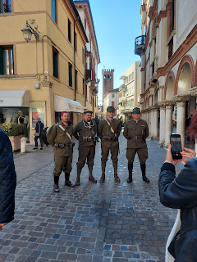

Then I purposely got lost by walking around wherever my feet took me.

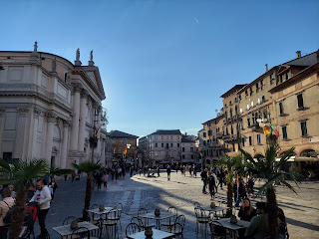

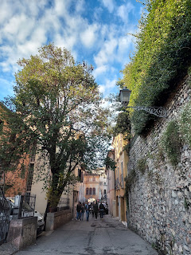

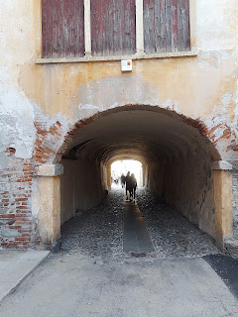

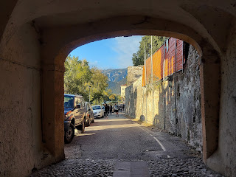

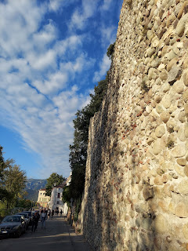

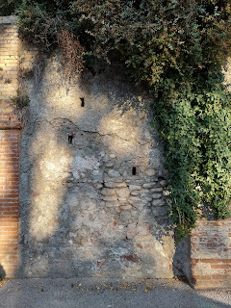

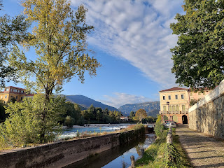

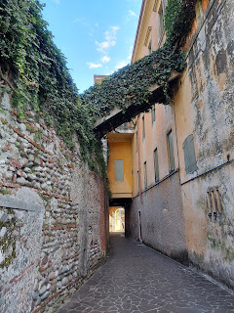

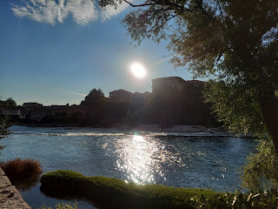

Note - you should never wear heels on the cobble stone streets. Never. Unless you have a death wish.

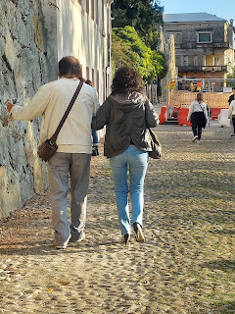

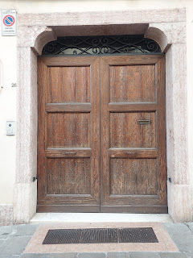

And that's all. That's the whole week!

Today is Sunday. I took the day off from any sightseeing. I have stayed in the hotel all day so far. I listened to the Sunday afternoon session of General Conference this morning in its entirety. So now I am all caught up with conference! That feels really good! I loved everything I heard and felt, and I have some notes of things I want to work on for the next few months.

This coming week - beginning tomorrow - Monday - I will be in Aviano and visiting my Italian kids, Benson and Kylie. Hooray!!! And in one week, next Sunday, I will be making my way back to the United States. Double Hooray!!! I can't wait. It's been great, believe me. But I can't wait to get home. Home is where the heart is. It's also where my husband is.